OPEN BIBLE CHRISTIAN ACADEMY
2022-2023 DRESS CODE

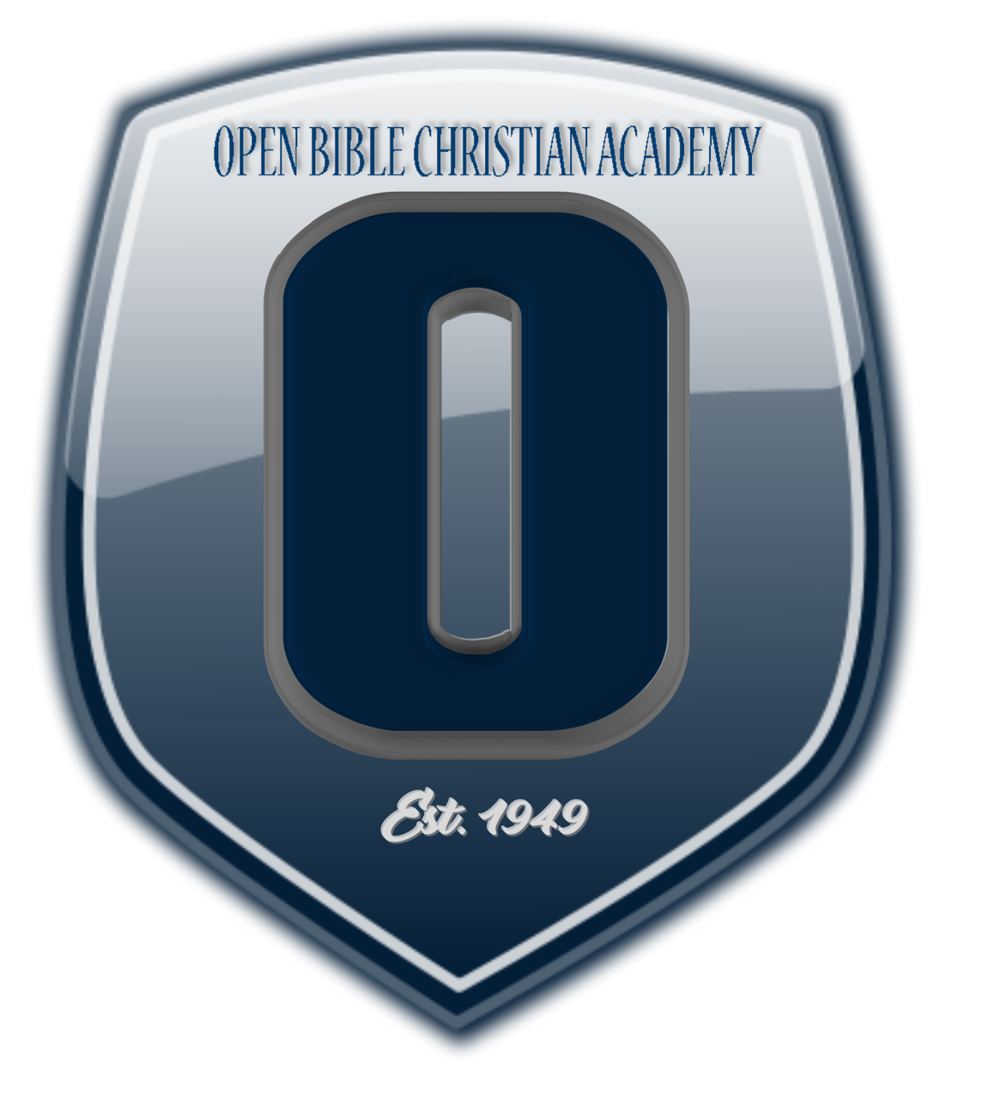
Students are expected to comply with the dress code. Uniforms can be purchased from Flynn and O’Hara, 8868 Waltham Woods Rd, Parkville, MD (410-828-4709). The web site is www.flynnohara.com or call 1-800-441-4122 to place orders by phone. You may choose an alternate uniform supplier; however, the style and color must match that of Flynn and O’Hara. When purchasing from department stores such as J.C. Penney, Sears, and Wal-Mart, purchase in the “Uniforms” department. When parents purchase items other than those from Flynn and O’Hara the school reserves the right of approval. Non-compliance with the standardized uniform look could result in disciplinary action.

General Rules for All Students

1. All hemlines must be at the top of the knee.
2. All shirts may have only the top button unbuttoned; shirttails will be tucked in at all times.
3. All clothing must be clean, in good repair, and fit properly.
4. Jewelry-
a) No drop or dangled earrings (middle and high school small dangle or hoop).
b) No earrings allowed for boys.
c) No jewelry may be worn in other pierced body parts.
d) No body art or tattoos.
e) Students may wear necklaces, rings, and bracelets as long as they are in good taste.
f) The Administration reserves the right to ask a student to remove any jewelry that it felt not appropriate.
5. No sandals, flip flops, platforms, chunky heels, or mules.
6. Hats may be worn to school but not in buildings or in class.
7. Hair -
a) Must be neat and well groomed and out of the eyes.
b) No unusual cuts or styles.
c) No unnatural colored hair.
d) The length of boy’s hair must not be more than half covering the ears and may not touch the collar.
8. Fingernail polish should enhance a ladylike appearance.
9. Make-up for high school girls must be modest and discreet. No make-up in lower or middle school.
10. Polo shirts, blouses, white dress shirts (if not purchased from uniform company) must be generic: i.e. no lace ruffles on blouses, no extra styling, no logos.
11. All blouses and shirts must be heavy enough that underwear does not show through.
12. High school boys – no facial hair (no mustaches, beards, goatees, or long side burns).

K3, K4, K5: No uniform required

